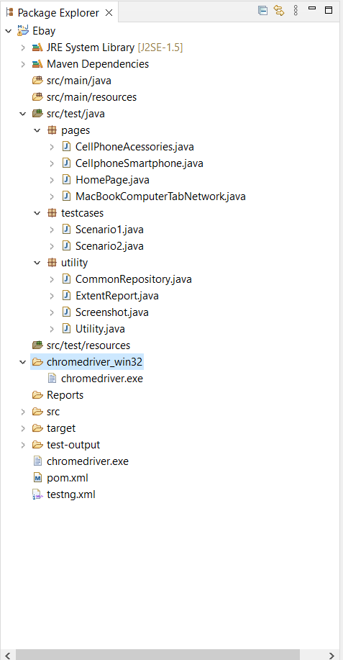

The given assignment had 2 scenarios and the solution is named as per that.

Inside the testcases packages there are two classes named Scenario1 and Scenario2 which are testing classes and can be executed separately to view the result.

We have testing.xml and that can be used to run both the scenarios together.,